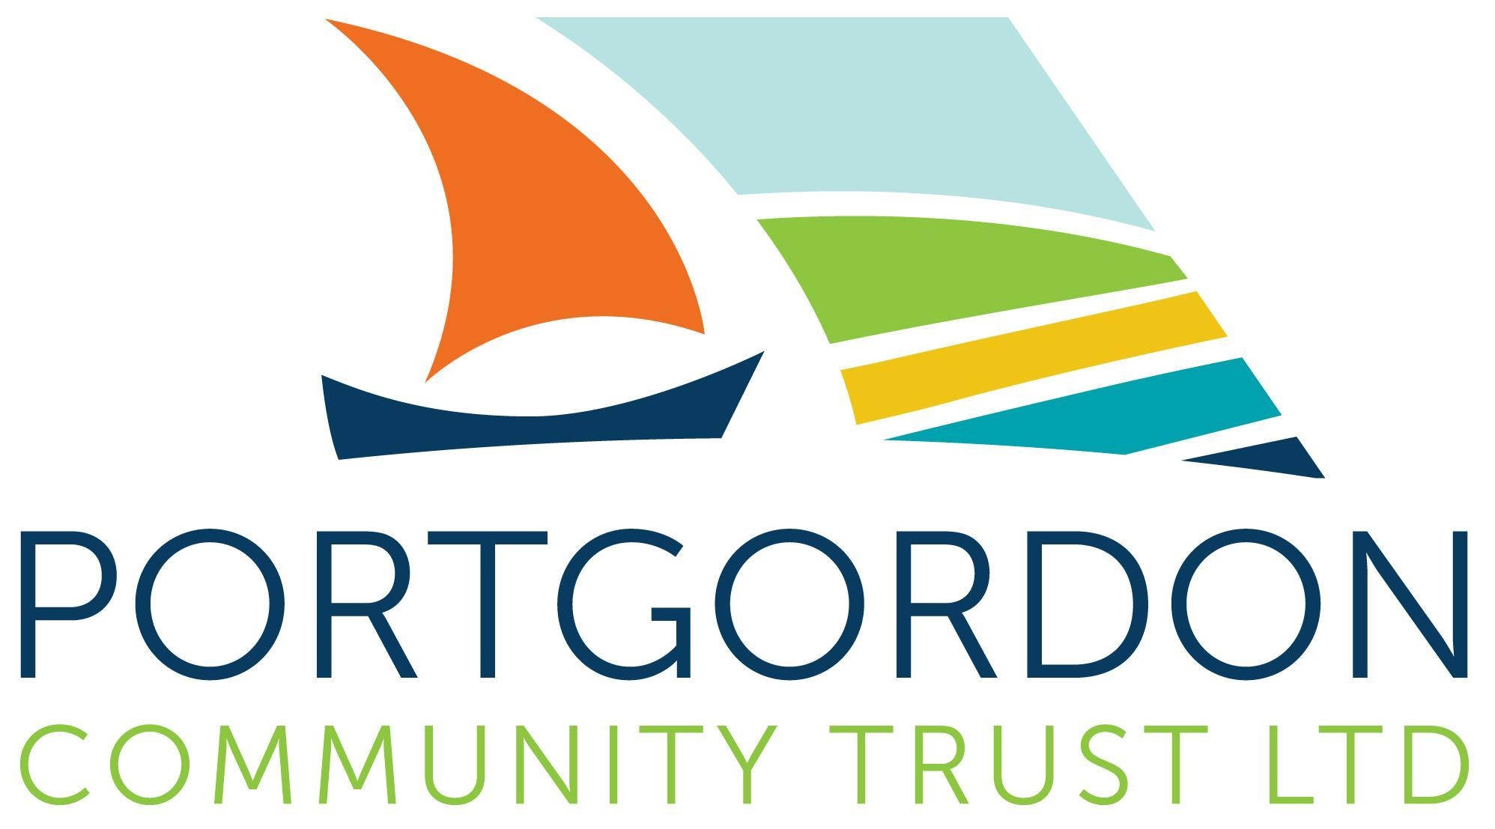

Portgordon

Community Emergency Plan Draft for comment

Plan Last Updated: 04/07/2024
Version 4

IF YOU ARE IN IMMEDIATE DANGER, CALL 999

This plan exists to complement the work of the emergency services and is not a substitute for calling 999.

Summary of what you can do to help:
Portgordon has identified a safe meeting space: Portgordon Village Hall.
- We can provide up to 20 emergency grab bags which contain basic items to support households.
- Sharing information through community social media.
- Teas, coffee, soup – self make

The location of a Rest Centre (led by Moray Council) is a dynamic decision taken in response to each events unique response requirements. The Council has a list of properties it can utilise as Rest Centre’s. Safe spaces are run by CRG’s there will be no council resources in place at these locations. There will be liaison between CRG’s management and Council Management during an event.

Snapshot View of your Community:

Area Characteristics:
- Higher than average population of elderly that require heat, light & food
- The village has 2 specific areas – upper Portgordon & Lower Portgordon
- Close to the North Sea with risks of flooding and debris
- A Harbour that has suffered storm damage.
- We have 2 community owned assets and a LA owned school buildings

At Risk Groups:
- Elderly
- Those with medical / health /disabilities
- Travelling communities that reside outside Portgordon

Previous Significant Emergency Events:
- Covid 19 Pandemic
- 2013 – 2014 – Storm damage to the harbour pier
- Flooding/Debris to Stewart Street
- 2018 -2021: Fire along shoreline
- Adverse Weather – when blocking the A98, traffic is diverted through Portgordon causing significant disruption
- Power failures

Plan Distribution List:emergen
Name | Role | Phone number/email address | Issued on
Ross Ferguson | Emergency Planning Officer | Ross.ferguson@moray.gov.uk | 02/02/2023
Village Hall | Safe Place | TBC

Plan Amendment List:
Date of Amendment | Date for Next Revision | Details of Changes Made | Changed By
02/02/2023 | TBC | Version 1 of Portgordon Emergency Plan | Michelle Good
10/05/2023 | May 31st, 2023 | Version 1 Finalised | Michelle Good & Rhona McNicol
13/03/2024 | April 2024 | Review of whole document with newly formed group | Michelle Good  Neil Bruce  Anne Stewart
04/07/2024 | TBC | Updated terminology and into to rest centres vs safe space | Michelle good with support from Ross Ferguson

Contents:
Plan Distribution List 3
Plan Amendment List 3
Contents 4

Local Risk Assessment & Actions 5
Local Skills/ Resources Assessment 6
Key Community Locations 7
Organisation Emergency Co-Ordinator(s) 8
Activation Triggers 9
First Steps in an Emergency 10
Actions Agreed with Emergency Responders (Evacuation) 11
Alternative Arrangements for Staying in Contact 11
Key People (Staff/ Managers) 12
Alternative Premises 12
Suppliers 13
Key Customers/ Service Users 13
Neighbouring/ Support Organisations 14
Emergency Services (Non-Emergency/Local) 14
IT & Cyber Security Support 15
Utilities Providers 15
Any Other Useful Contacts 17
Disclaimer 11

Local Risk Assessment & Actions:

Risks | Impact on Community | Possible Actions  (What can your organisation do to assist the emergency services?)
Rough Seas – flooding and debris | - Flooding of local streets  - Blocked Access to Stewart Street from either side  - Damage to residents’ properties  - Road traffic incidents  - Power failing of Sewage Pump on Stewart Street (MC response) | - Report to Moray Council and emergency services on the situation.  - Share through social media platforms  - Assist Cat 1 responders where required
Fires | - Travelling smoke  - Lower visibility  - Inc incidents in Business premises | - Report to emergency services.  - Share updates through social media platforms from official emergency service sources.
Food and Fuel Poverty | - Risk of people unable to access heat and food | - Signpost to other support services  - Seek support from PCT.  - Assist Cat 1 responders where required
Flooding inc Collapse of Harbour wall or damage to piers and sea defences. | - Damage to property/gardens  - Blockages to piped watercourses | - Raise awareness of personal household resilience  - Report any damages to Strutt & Parker  - Report to MC  - Inform emergency services if required  - Assist Cat 1 responders where required

Local Skills and Resources Assessment:
Resource | Name/ Owner / Trained Person | Location of Asset | Contact details | When are they unavailable?
Defibrillator | Paul Macpherson | The Village Hall  Cross Street  Portgordon  AB56 5QW | 07740 971 131 | ?
Poly Tunnels for shelter, gardening tools, food, solar panels for basic electrics) | Garden Group | The Garden Group  1 Gordon Square, Portgordon, Buckie  AB56 5RG  (Harbour) | 07399 031 253  (via Michelle Good) | Summer Opening Hours: 8am - 9.30pm (closed from 4pm-5pm)  (Access can be arranged via Trust)
20 Emergency Packs: Sleeping bags with liners, food flasks, portable gas stove and cylinder, heat packs, blankets, landline telephones, mobile phone power-banks, reflective jackets, head torches, wind up radio/ torch/ phone charger, light sticks and strip thermometers. | Portgordon Resilience Group | Portgordon Community Hub  19-21 West High Street  AB56 5QS | 07399 031 253  (via Michelle Good) | Available on request
Camp beds (x 10) | Portgordon Resilience Group | Portgordon Community Hub  19-21 West High Street  AB56 5QS | 07399 031 253  (via Michelle Good) | Available on request
Portable Power Pack – Ecoflow Delta Max | Portgordon Resilience Group | Portgordon Community Hub  19-21 West High Street  AB56 5QS | 07399 031 253  (via Michelle Good) | Available on request
Motorola Radios (x8) (10km range) | Portgordon Resilience Group | Portgordon Community Hub  19-21 West High Street  AB56 5QS | 07399 031 253  (via Michelle Good) | Available on request
Trailer (tilt) | Portgordon Community Trust | Portgordon Community Hub  19-21 West High Street  AB56 5QS | 07399 031 253  (via Michelle Good) | Available on request
Electronic Vehicle Charging Point | The Village Hall  Cross Street  Portgordon  AB56 5QW | The Village Hall  Cross Street  Portgordon  AB56 5QW | 07399 031 253  (via Michelle Good) | 24 hour access
More can be added when elicited at a community resilience event

Boxes in Yellow are still to be confirmed

Key Community Locations:
Building  Name | Location | Potential Usage in an Emergency | Contact details
Portgordon Village Hall | Cross Street, Portgordon, AB56 5QW | Kitchen  Accessible Toilets  Heating  Electric  2 x Large Floor Area | Portgordon Village Hall Committee key holders.  TBC
Portgordon Community Hub | 19-21 West High Street, Portgordon, AB56 5QS | 2 x Showers (top floor only)  Kitchen  Toilets | Portgordon Community Trust Board of Directors
Portgordon Community Centre | Richmond Terrace, Portgordon AB56 5RA | Group needs to contact Moray Council for more details | Moray Council?

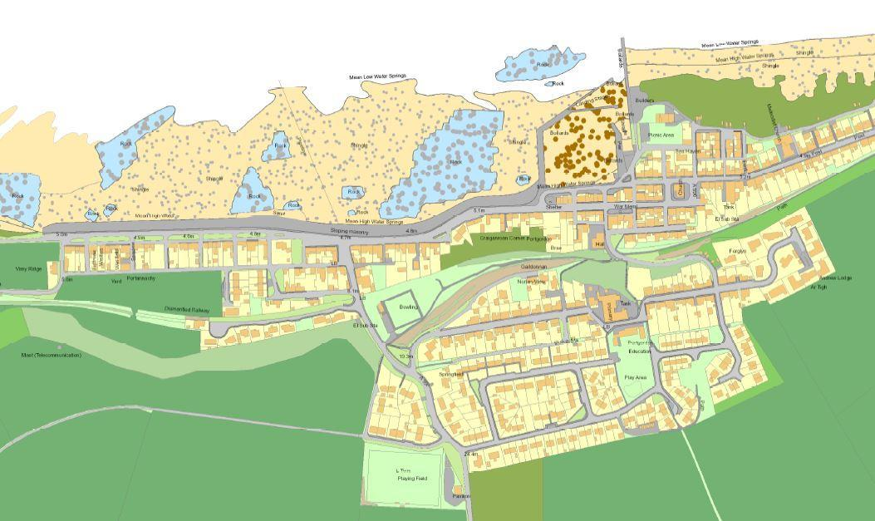

Resilience Plan Co-Ordinators:

(Paul to send photo 10/05/2023) | Name: Paul MacPherson
(Paul to send photo 10/05/2023) | Title: Resilience Plan Coordinator
(Paul to send photo 10/05/2023) | 24hr telephone contact: 07740 971 131
(Paul to send photo 10/05/2023) | Email: paulmacpherson@yahoo.com
(Paul to send photo 10/05/2023) | Address: 22 Richmond Terrace, Portgordon, AB56 5RA

(TBC) | Name:
(TBC) | Title: (Vice) Resilience Plan Co-Ordinator
(TBC) | 24hr telephone contact:
(TBC) | Email:
(TBC) | Address:

Resilience Plan Coordinator, Draft Communication Tree

Paul Macpherson
Resilience Plan Coordinator
07740 971 131

VICE CHAIR

Michelle Good
07399 031 253
Third contact, if necessary
Key Group Member 1 is responsible for calling:

- Member 4, tel number
- Member 5, tel number
- Member 6, tel number

Key Group Member 2 is responsible for calling:

- Member 7, tel number
- Member 8, tel number
- Member 9, tel number

Key Group Member 3 is responsible for calling:

- Member 10, tel number
- Member 11, tel number
- Member 12, tel number

This can be built up/adapted in a way that suits our approach

- Remember to record mobile and landline numbers. If telecommunications fail, refer to alternative arrangements for communication.

:

Activation Triggers | Emergency Response
Rough Seas – flooding and debris | - Report to Moray Council and emergency services on the situation.  - Share through social media platforms  - Assist Cat 1 responders where required
Fires | - Report to emergency services.  - Share updates through social media platforms from official emergency service sources.
Food and Fuel Poverty | - Signpost to other support services  - Seek support from PCT.  - Assist Cat 1 responders where required
Flooding inc Collapse of Harbour wall or damage to piers and sea defences. | - Raise awareness of personal household resilience  - Report any damages to Strutt & Parker  - Report to MC  - Inform emergency services if required  - Assist Cat 1 responders where required

This is a organic and may change as we respond to need & experience

Under no circumstances will we put ourselves or others at risk to fulfil these tasks.

Actions Agreed with Emergency Responders in the Event of an Evacuation:
- Be directed by emergency services, if requested.

Emergency Services on Scene will direct operations to an incident response and they may request CRG’s to support in that response. This will not be in a direct manner or in a way that puts a person at risk. Most likely the request will be for Safe Space to open and be available.
Ongoing: promoting awareness of the community resilience group working and support in Portgordon.

Alternative Arrangements for Staying in Contact (if usual communications have been disrupted):
Communication Type | Name of Contact | Location
Radios (Motorola 10km, x8)  (*Channel to be decided) | Paul Macpherson | Portgordon Community Hub, 19-21 West High Street, Portgordon, AB56 5QS

Communications Plan
Documentation is being created to detail the availability of equipment, its maintenance and usage. Along with this, details of contact numbers for community volunteers will be kept as will be those of other agencies that may be requested to assist.

Instructions for the Communications Unit Leader will be given so that any person tasked with this role will have a guidance document to assist them in the management of this vital component of any incident.

It is envisaged that the document will contain details of communications when all systems are available to the group; when normal communications are not available (failure of local mobile masts, for example) and integration with other agencies and their communications systems or procedures.

Some training in radio communications will be necessary but details of radio use, procedures and etiquette will also be listed in the communications plan as a reminder to Group responders.

Emergency Contact List:

Chair of Lennox CC:
Name: TBC
Telephone:
Email:
Address:

Secretary of CC:
Name: Pringle George
Email: lennoxcommunitycouncil@gmail.com

Incident Command Point for Emergency Group to Meet:
Location Name: Portgordon Village Hall
Contact: TBC
Address: Cross Street, Portgordon, AB56 5QW
Alternative Contact: *Name and number required

Alternative Safe Premises:
Location Name: Portgordon Community Hub
Contact: TBC
Address: 19-21 West High Street, Portgordon, AB56 5QS
Alternative Contact: *Michelle to ask Derek

Neighboring/Supporting Community Council: Buckie & District

Contact:
Allan Paterson allanjpaterson@outlook.com 07825 599 091
Jacobus Boonzaaier Jboonzaaier@churchofscotland.org.uk 01542 649644

Alternative Contact: Stephanie Lindsay, https://www.facebook.com/buckieanddistrictCC

Emergency Services:
101 non-emergency | 999 emergencies

Local Police Station: (CRG to discuss)
Telephone:
Address:

Local Fire Station:
Telephone:
Address:

Local Hospital: Dr Grays Hospital
Telephone:
Address:

Local GP Practice: Seafield & Cullen Medical Group
Telephone: 01542 835 577
Address: Seafield Medical Centre, Barhill Road, Buckie, AB56 1FP

Electricity (24hr faults):
Landline: 105

Gas (24hr emergency):
Landline: 0800 111999

Water (24hr):
Landline: 0800 0778778

Any Other Useful Contacts:
(Local Businesses/ Owners, Associations, Trusts, Community Groups, SSEN, SEPA, Scottish Flood Forum etc)

Spar 6 Station Road, Portgordon, AB56 5RZ 01542 834 777
- Can open in the event of an emergency, contact through co-ordinator

Grissans TBC

Maltings TBC

William Grant & Sons TBC

GRIT BINS IN PORTGORDON:
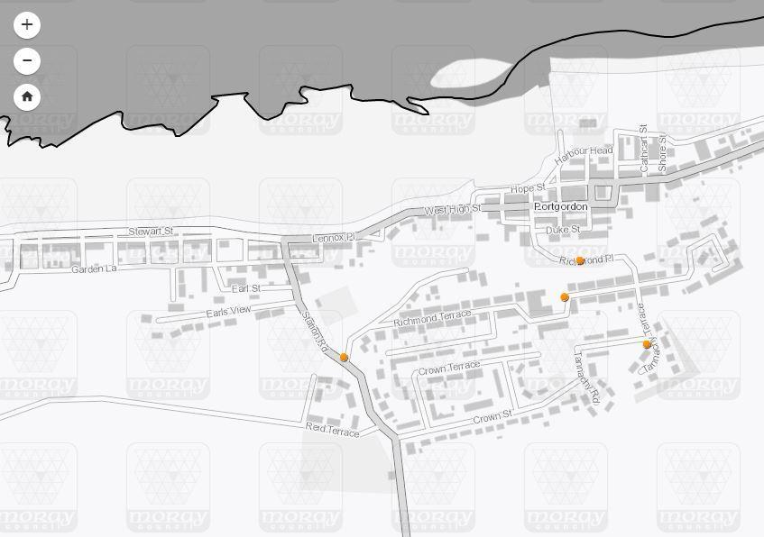

Map requires updating - 4 bins located. An additional 2 have been put in on Earls View and Earls Street.

Disclaimer:
The following key points have been borne in mind when completing this template:

• This document neither implies nor intends any formal role for organisations, villages, towns or any part of the community (collectively called the ‘community) in the response to, or recovery from, emergencies.

• There is no role implied for the organisation or community in support of the emergency services in their response to incidents.

• The completion of the document template, in part or in full, is entirely voluntary and is the responsibility of the local community.

• All completed risk assessments and accompanying plan documents will be shared with the Community Support Unit for their own records and will be subject to periodic review by the responding community council.

• On the appointment of plan co-ordinators, these individuals will complete training with the Moray Council on roles, responsibilities and accountability.

• Following the completion of this template, the community council will enact a period of scenario testing in their community. This can be done in partnership with neighbouring community councils.

• While the local community has no formal role, there is widespread recognition of the value of planning from the lowest practicable level upwards to help cope with potential local emergencies.

• The need to complete any part of the template, or the requirement to include other relevant information, will depend on the nature and composition of the community and the likely hazards.

• The Moray Council, Community Support Unit and other local public sector representatives can provide advice and assistance where requested, and where relevant, to support the completion of the template.

• The organisation/ local community is encouraged to submit a copy of the completed template to the community council liaison officer: cclo@moray.gov.uk

• Significant amendments to the completed template, especially changes in contact details, will be shared with the Community Support Unit via the community council liaison officer.

Signed by Lennox Community Council Member: Date:

Signed by Plan Co-Ordinator(s): Date:

Signed by Plan Co-Ordinator(s): Date:

*Recommended signatories: Paul and Vice Co-Ordinator plus a different member of Lennox CC?

Template prepared by:
Community Support Unit (CSU)

The Moray Council
Community Support Unit
01343 563 346
CSU@moray.gov.uk

Ready Scot (2020) Guide to emergency planning for community groups. https://ready.scot/get-involved/community-groups/guide-emergency-planning-community-groups/templates

HTSI (2021) The Highland Resilience Network. www.highlandrn.co.uk

